**CHAPTER 1**

**INTRODUCTION**

The search for an empty parking spot can become an agonizing experience for the city’s urban drivers. A recent article claims that drivers cruising for a parking spot in SF generate 30% of all downtown congestion. These wasted miles not only increase traffic congestion, but also lead to more pollution and driver anxiety. In order to alleviate this problem, the city armed 7000 metered parking spaces and 12,250 garages spots (total of 593 parking lots) with sensors and introduced a mobile application called SFpark, which provides real time information about availability of a parking lot to drivers.

However, safety experts worry that drivers looking for parking may focus too much on their phone and not enough on the road. Furthermore, the current solution does not allow drivers to plan ahead of a trip. We wish to tackle the parking problem by (i) predicting the occupancy rate, defined as number of occupied parking spots over total number of spots, of parking lots in a given future time (ii) working on aggregated parking lots to explore if there is estimation error reduction pattern in occupancy prediction, (iii) classifying daily parking occupancy patterns to investigate different travel behaviour at different time. Automatic Number Plate Recognition and Parking Occupancy Prediction System (ANPR&POPS).

**CHAPTER 2**

**SCHEDULE**

A schedule is a listing of project’s milestones, activities and deliverables, usually with intended start and finish dates. Those items are often estimated in terms of resource allocation, budget and duration, linked by dependencies and scheduled events. A schedule is commonly used in project planning and in project management. There are several types of inputs to create a project schedule.

* personal and project calendars
* description of project scope
* project risks
* list of activities and resource requirements

The graphical representation of the project’s activities, the time takes to complete them and the sequence in which they must be done is typically created by using Gantt chart and PERT charts. Because of the uncertainty involved, the schedule is reviewed regularly, and is often revised while the project is in progress.

**2.1 List Of Resource**

The resources meant to the human resources needed in each stage of the scheduled functions. These are listed in the figure 2.1

|  |  |  |  |  |
| --- | --- | --- | --- | --- |
| **Sl no:** | **Name** | **Type** | **Email address** | **Max Units** |
| 1 | Software Engineer 1 | Work | souravak211@gmail.com | 100% |
| 2 | Software Engineer 2 | Work | mithunmsman123@gmail.com | 100% |
| 3 | Software Engineer 3 | Work | adithyanmm17@gmail.com | 100% |

**Figure 2.1 List of Resources**

**2.2 Plan Document**

The plan document given the figure 2.2 indicates the scheduling of each activity in the development of the Automatic Number Plate Recognition and Parking Occupancy Prediction System. The Project started on June 1, 2022. Each row provides the time scheduling and the resource allocated to the activity.

|  |  |  |  |  |  |  |
| --- | --- | --- | --- | --- | --- | --- |
| Sl no: | Name | Duration | Start Date | Finish  Date | Predecessors | Resource Name |
| 1 | **Inception** | 7 days | 14/06/2022 | 20/06/2022 |  |  |
| 2 | Requirement Analysis | 3 days | 14/06/2022 | 16/06/2022 |  | Software Engineer 1 |
| 3 | Use case development | 3 days | 16/06/2022 | 18/06/2022 | 2 | Software Engineer 2 |
| 4 | Screen prototype development | 2 days | 18/06/2022 | 19/06/2022 | 3 | Software Engineer 3 |
| 5 | Screen prototype approval | 1 day | 19/06/2022 | 19/06/2022 | 4 | Software Engineer 3 |
| 6 | Cost estimation | 1 day | 21/06/2022 | 21/06/2022 | 5 | Software Engineer 2 |
| 7 | **Elaboration** | 4 days | 24/06/2022 | 27/06/2022 |  |  |
| 8 | ER diagram | 1 days | 26/06/2022 | 26/06/2022 | 6 | Software Engineer 3 |
| 9 | Gantt chart development | 1 day | 28/06/2022 | 28/06/2022 | 7 | Software Engineer 3 |
| 10 | App flow development | 2 days | 29/06/2022 | 30/06/2022 | 8 | Software Engineer 1 |
| 11 | **Construction** | 20 days | 01/07/2022 | 20/07/2022 |  |  |
| 12 | Develop UI | 3 days | 02/07/2022 | 04/07/2022 | 9 | Software Engineer 2 |
| 13 | Develop source code | 16 days | 03/07/2022 | 18/07/2022 | 10 | Software Engineer 2 |
| 14 | Source code review | 2 days | 18/07/2022 | 20/07/2022 | 11 | Software Engineer 3 |
| 15 | Unit testing | 1 day | 20/07/2022 | 20/07/2022 | 12 | Software Engineer 3 |
| 16 | Integrated testing | 1 day | 21/07/2022 | 21/07/2022 | 13 | Software Engineer 1 |
| 17 | System testing | 1 day | 21/07/2022 | 21/07/2022 | 14 | Software Engineer 1 |
| 18 | **Transition** | 1 day | 22/07/2022 | 22/07/2022 |  |  |
| 19 | Deployment to user | 1 day | 23/07/2022 | 23/07/2022 | 15 | Software Engineer 3 |

**Figure 2.1 Plan Document**

**2.3 Gantt Chart**

Figure 2.3 shows the Gantt chart of the scheduled activities. A Gantt chart is a useful graphical tool which shows activities or tasks performed against time.

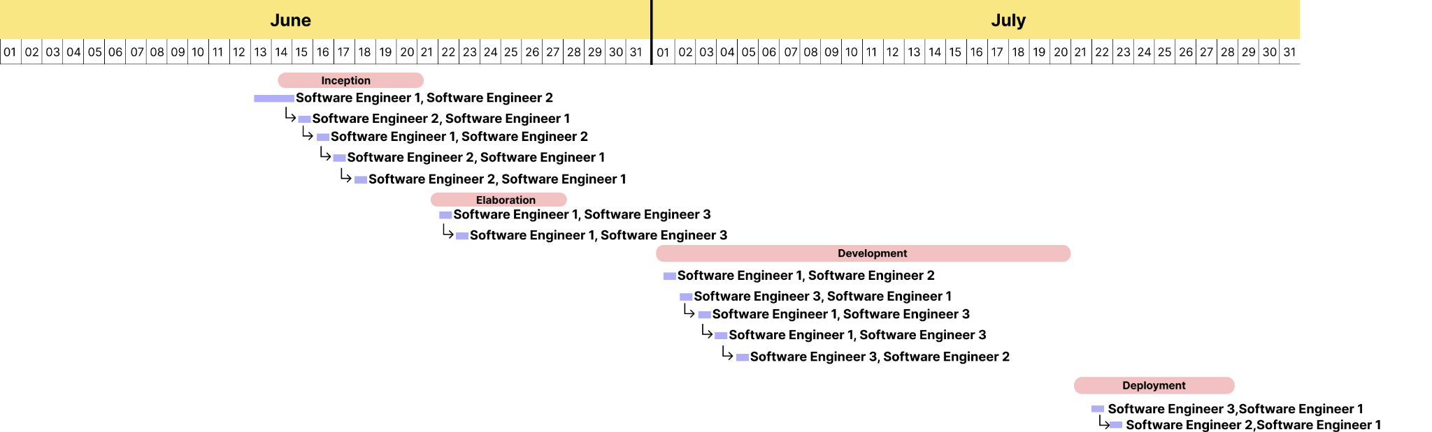

**Figure 2.3 Gantt chart**

**CHAPTER 3**

**CONCLUSION**

With this project, an effective method of identification of vehicle number plate is proposed which is less time consuming and applied to various types of pictures. Edges could be recognized here through the use of the SOBEL edge detection method, and also the holes are filled but with far less than 8 pixels. To retrieve the vehicle's number plate, we delete attached parts / pieces and under 1000 pixels. Our proposed set of computer instructions is mainly based on Indian car number plate scheme, the accuracy of extracting the number plate for low quiet mood can be increased, as well as we can detect the number plate that has different font size and also different font type.